Dr. Mahmoud Ayoub

Publications & Articles
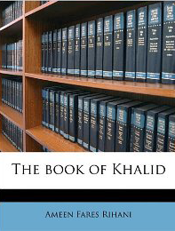
“The Book of Khalid,” al-Arabiyya, 9, 1-2 (1976), 19-25. Publication of my remarks for a panel discussion on the works of Amin al-Rihani, a Lebanese-American author, at the Middle East Studies Association meeting of 1974 in Los Angeles.
TESOL Placement Quarterly. Washington, D.C.: Center for Applied Linguistics, 1980-81 (Executive Editor)
The Congregational Ranger. Hartford: Fellowship of Connecticut Congregational Christian Churches, 1988-97 (Executive Editor)
“The Arabic Language Manuscript Collection in Hartford,” Muslim World, LXXX, 1 (1990), 56-7.
The Arabic Manuscript Collection: Interim Report. Hartford: Hartford Seminary, 1991. (Inventory of the Seminary’s collection of over 1700 Arabic language mss.
“Mysteries of the Scribes,” in The Illuminated Manuscripts of Hartford Seminary. Hartford: Hartford Seminary, 1994.
“How God Speaks”, The Congregationalist, 159, 3 (1999), 12-14.
“‘Who Is My Neighbor?’ Reflections on the Anniversary of September 11”, The Congregationalist, 162, 3 (2002), 24-27.
“Christianity and Islam in an Early Arabic Version of the Book of Job: The Interplay of Theology and Translation,” Slovo, Vol. 3 (Fall 2000), pp. 1-10.
“Islamic Perspectives on Jerusalem,” ZH Online (2006)

