ISLAMIC SPIRITUALITY WS-639
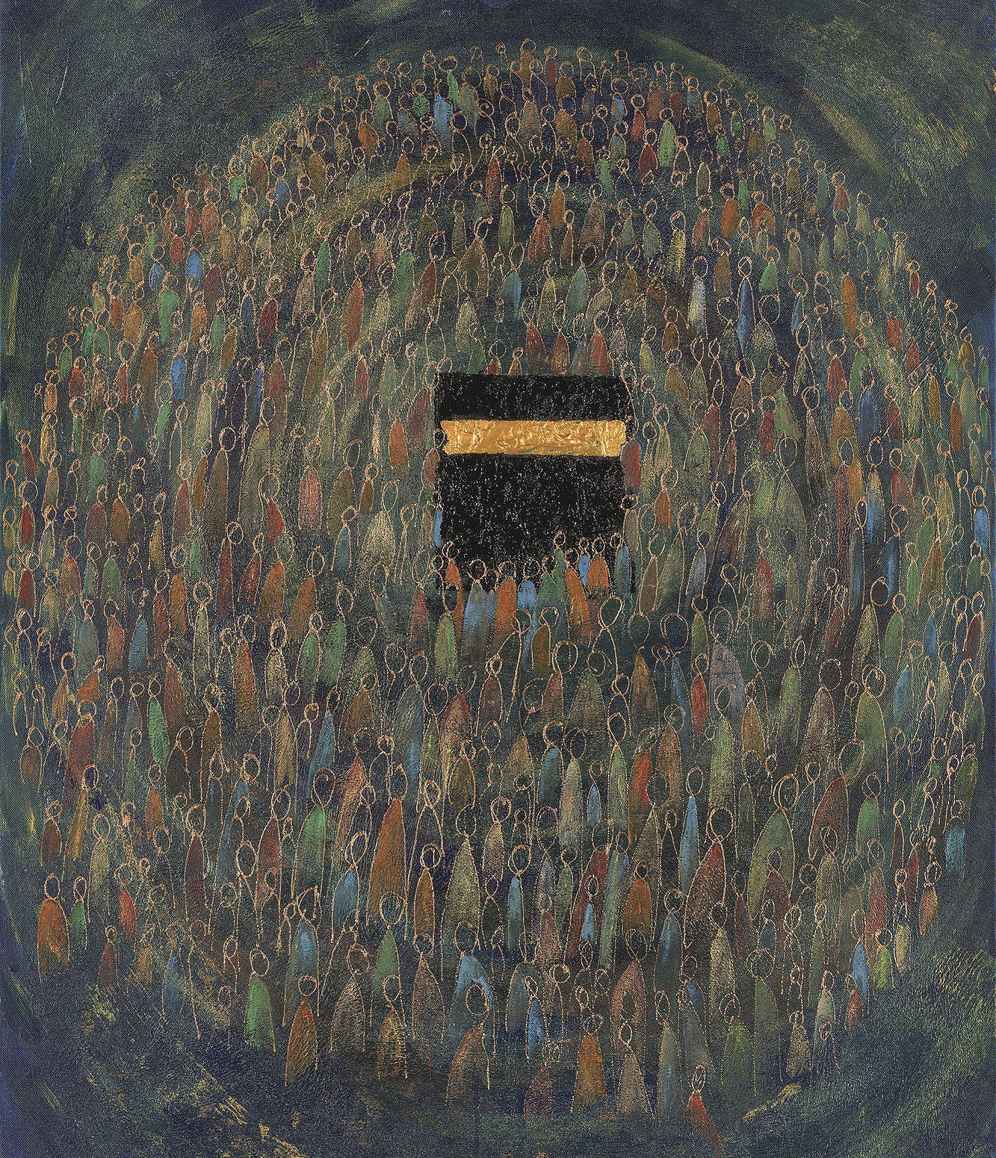
Fall 2025
Hartford International University for Religion and Peace
Colleen M. Keyes, Ph.D.
ckeyes@hartfordinternational.edu
Course Description
This course explores the growth of the Islamic spiritual tradition from the earliest days of Islam. It aims to help students know the diverse manifestations of this spiritual tradition; to examine the historical contexts in which Muslim spiritual paths, practices, and communities developed. We will read both primary sources in translation and secondary sources, reflect on the teachings of a cross-section of Muslim spiritual masters, learn about the development of Sufism as one manifestation of Islamic spirituality, and consider diverse positions on forms and practices of Islamic spirituality. We will encounter English translations of some of the greatest masterpieces of Sufi Arabic and Persian literature, works which inspire both Muslim and non-Muslim practitioners of spirituality. This course explores how the spiritual dimension of Islam in its diverse forms animates Muslim life and inspires seekers of the Divine around the world.
Required Readings: (If material is not on the Digital Theological Library, you are expected to acquire a copy prior to the start of classes.)
Attar, Farid al-Din, Dick Davis, and Afkham Darbandi, The Conference of the Birds, Hammondsworth, Middlesex, Penguin Books, 1984. PDF-online)
https://sufipathoflove.files.wordpress.com/2019/10/the-conference-of-the-birds.pdf
Martin Lings, What is Sufism? Cambridge: The Islamic Texts Society, 1995.I
Michael Sells, Early Islamic Mysticism: Sufi, Qur’an, Miraj, Poetic and Theological Writings.
Paulist Press, 1996.

Imām Mawlūd's Maṭharat al-Qulūb, Signs, Symptoms and Cures of the Spiritual Diseases of the Heart, trans. Hamza Yusuf. PDF.

Course Learning Objectives: Upon successful completion of the course, students will be able to
- Locate the roots of the spiritual dimension of Islam in the Qur’an and the life of the Prophet Muhammad (PBUH)
- Demonstrate understanding of the centrality of virtue and ethical development in Islamic spirituality
- Identify key figures in Muslim spiritual thought and practice and explain their significance.
- Demonstrate familiarity with the principles of Sufism
- Demonstrate appreciation of Sufi poetry as a form of spiritual inspiration and teaching.
This course assists students in achieving the following program outcomes through its content, learning activities and assignments and their assessment:
Master of Arts in Interreligious Studies (MAIRS): Learning Outcomes
- To demonstrate foundational and critical knowledge of one’s own religion
- To demonstrate the knowledge, capacities, and willingness to respectfully engage other religions and world views
- To demonstrate knowledge of the practices of one’s own religious tradition and the capacity to appreciate the practices of other religious traditions
Master of Arts in Chaplaincy (MAC): Learning Outcome # 3: Possess concrete skills for working in a multi-faith environment…developed both in the classroom and through supervised field work.
Course Requirements:
- Attendance, active participation and preparedness in each class session (60%): Students shall attend class each week for two hours via Zoom having done the assigned reading and any assignments in advance of the class hour. Students are to be prepared to respond substantively regarding the assigned reading, lecture, or other assigned material.
- Quizzes, Exams, Presentations, and Written Assignments --40%
Course Reading Schedule: (may be modified as necessary) Written assignments will be given in class for the discussion online. Assignments to make presentations will be given after the first 2 weeks.
9/4: Lings, Chapters 1-4.
9/11: Lings, Chapters 7-9
9/18: Sells, Ch. 1-Sources of Islamic Mysticism
9/25: Sells, Ch. 2- Early Sufi Qur’an Interpretation

10/9: Sells, Ch. 3—Qushayri

10/16: Sells, Ch. 4—Rabi ‘a; Helminski, Readings from Women of Sufism

10/23: Sells, Ch.5— Muhasibi; 1 hour in class Mid-Term Exam; Submit Book Reflection

10/30: Sells, Ch. 6—Sarraj; Ch. 7—Bistami

11/8: Sells, Ch. 8—Junayd; Ch. 9—Hallaj

11/15: Yusuf, pp 12-72

11/22: Yusuf, pp. 76-98

12/4: Attar, The Conference of the Birds

12/11: Attar, The Conference of the Birds

12/15: Submit Book Reflection

Course Expectations and Policies:
Be fully engaged Complete reading, writing, and/or discussion assignments by the assigned due date and be prepared to participate fully in class. Demonstrate high commitment to all aspects of the course.
Respectful interaction with instructor and fellow students is essential in person, online, and in written communications.
Assignment expectations:

- Assignments must be on time—no exceptions
- Integrity/Honesty. You are expected to do your own work honestly though you are allowed to access the help of a writing tutor or guide. However, plagiarism is a serious academic offense which involves using the work or intellectual property or creation of another person in whole or in part without proper attribution of credit to the author.

Here is the full statement in the HIU policy on what plagiarism is:
“Plagiarism, the failure to give proper credit for the words and ideas of another person, whether published or unpublished, is strictly prohibited. All written material submitted by students must be their own original work; where the words and ideas of others are used they must be acknowledged. Additionally, if students receive editorial help with their writing they should also acknowledge it appropriately.
Credit will not be given for work containing plagiarism, and plagiarism can lead to failure of a course. Faculty will report all instances of plagiarism to the Academic Dean. The Academic Dean will then collect documented details of the case and advance any recommendations for further action to the Academic Policy Committee. Through this process the situation will be reviewed and any additional penalties that may be warranted (up to and including expulsion from the school) will be determined. For clarity as to what constitutes plagiarism, the following description is provided:
1. Word for word plagiarism: (a) the submission of another person’s work as one’s own; (b) the submission of a commercially prepared paper; (c) the submission of work from a source which is not acknowledged by a footnote or other specific reference in the paper itself; (d) the submission of any part of another person’s work without proper use of quotation marks.
2. Plagiarism by paraphrase: (a) mere re-arrangement of another person’s works and phrases does not make them your own and also constitutes plagiarism; (b) paraphrasing another person’s words, ideas, and information without acknowledging the original source from which you took them is also plagiarism. See Part II of Kate L. Turabian, A Manual for Writers of Research Papers, Theses and Dissertations, (7th Edition, University of Chicago Press, 2007) for an explanation of the proper ways to acknowledge the work of others and to avoid plagiarism.
3. Reuse of your own work: Coursework submitted for credit in one course cannot be submitted for credit in another course. While technically not plagiarism, this type of infraction will be treated in the same manner as plagiarism and will be subject to the same penalties. If you are using small amounts of material from a previous submitted work, that work should be referenced appropriately. When a student is writing their final program requirement (paper, project or thesis) it may be appropriate, with their advisor’s permission, to include portions of previously submitted materials if properly referenced.”

FULL INFORMATION ON THE CHICAGO STYLE (ALSO KNOWN AS TURABIAN STYLE) CAN BE FOUND AThttps://www.chicagomanualofstyle.org/home.html?_ga=2.247676996.232393886.1595472283-1231761653.1595472283

Accommodations—If you could benefit from writing assistance, or if you need some accommodations due to any type of disability, please contact the Student Services Coordinator.

HIU has a writing tutor and provides the following resources:
Research paper guide: http://www.https://www.hartfordinternational.edu/current-students/student-resources/student-writing-resources
The conventions of academic writing must be observed for each writing assignment.
Please learn what is permissible and what is not permissible when using the work and ideas of others. See the policy on plagiarism and the resources for writing. When in doubt, please ask the writing tutor or ask me. Ignorance of the rules and norms of academic writing is not an acceptable excuse at the graduate level.
HIU Policies can be accessed in the Student Handbook: https://www.hartfordinternational.edu/current-students/academics/academic-policies and https://www.hartfordinternational.edu/current-students/student-handbook/
MA and PhD Grading Scale
A (95-100) Demonstrates excellent mastery of the subject matter; has a superior ability to articulate this. Exceeds expectations of the course.
A- (90-94) Demonstrates mastery of the subject matter; articulates this well. Exceeds expectations of the course.
B+(87-89) Demonstrates a very good understanding of the subject matter, able to articulate ideas fluently and coherently. Meets expectations of the course.
B (83-86) Demonstrates an understanding of the subject matter and the ability to articulate lessons learned. Meets expectations of the course.
B-(80-82) Demonstrates an understanding of the subject, has some difficulty articulating this. Meets basic expectations for the course.
C+(77-79) Demonstrates a basic comprehension of the subject matter, weak articulation and connections. Does not meet expectations for the course.
C (70-76) Demonstrates a minimal comprehension of the subject matter, very weak articulation. Does not meet expectations of the course.
F (below 70) Unable to meet the basic requirements of the course.
BIBLIOGRAPHY
Required course books:
Attar, Farid al-Din, Dick Davis, and Afkham Darbandi, The Conference of the Birds, Hammondsworth, Middlesex, Penguin Books, 1984. PDF-online)
https://sufipathoflove.files.wordpress.com/2019/10/the-conference-of-the-birds.pdf

Martin Lings, What is Sufism? The Islamic Texts Society, 1995.

Camille Helminski, Women of Sufism: A Hidden Treasure—Writings and Stories of Mystic, Poets, Scholars and Saints, Boston: Shambhala Press, 2003.

Michael Sells, Early Islamic Mysticism: Sufi, Qur’an, Miraj, Poetic and Theological Writings.
Paulist Press, 1996.

Hamza Yusuf, trans. Purification of the Heart, Sandala Press, 2012. PDF.

